Huffman coding

* Huffman Algorithm was developed by David Huffman in 1951.
* This is a technique which is used in a data compression or it can be said that it is a coding technique which is used for encoding data.
* This technique is a mother of all data compression scheme.
* This idea is basically dependent upon the frequency, i.e. the frequency of the corresponding character which needs to be compressed, and by that frequency, only Huffman code will be generated.
* In case of Huffman coding, the most generated character will get the small code and least generated character will get the large code.
* Huffman tree is a specific method of representing each symbol.
* This technique produces a code in such a manner that no code word is a prefix of some other code word. These codes are called as prefix code.

**Example:**

Let obtain a set of Huffman code for the message **(m1...m7)** with relative frequencies **(q1...q7) = (4,5,7,8,10,12,20)**. Let us draw the Huffman tree for the given set of codes.

**Step 1)**Arrange the data in ascending order in a table.

**4,5,7,8,10,12,20**

**Step 2)** Combine first two entries of a table and by this create a parent node.

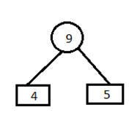

**Step 3)**

**A)** Remove the entries 4 and 5 from the table and inert 9 at its appropriate position. **7,8,9,10,12,20**

Combine minimum value of table and create a parent node.

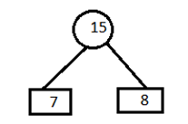

**B)** Now remove the entries 7 and 8 from the table and insert 15 at its appropriate position. **9,10,12,15,20**

Combine minimum value of two blocks and create a parent node.

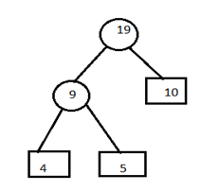

**C)** Remove the entries 9 and 10 from the table and insert 19 at its proper position. **12,15,19,20.**

Combine minimum value of two blocks and create parent node.

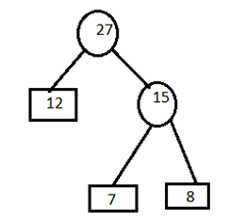

**D)** Remove the entries 15 and 12 from the table and insert 27 at its appropriate position. **19,20,27**

Combine minimum value of two blocks and create parent node.

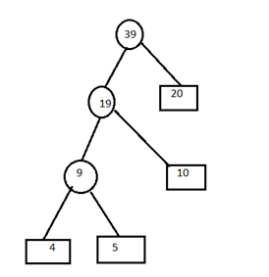

**E)** Remove the entries 19 and 20 from the table and insert 39 in the table. **27,39**

Combine minimum value of two blocks and create parent node.

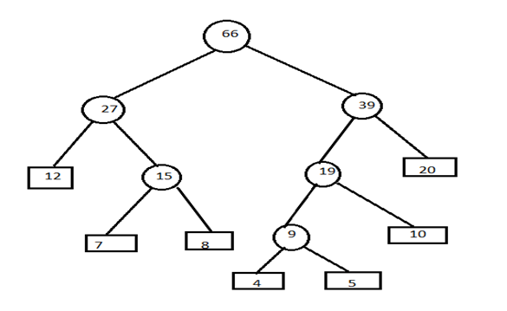

**Step 4)** Now assign left child as 0 and right child as 1 to encode the frequencies.

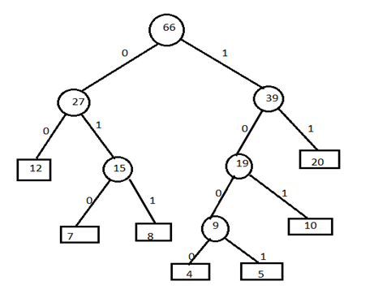

**Now, codes for the given frequencies are given below:**

